**User Engagement Analysis :"Why is the Tower of God Show So Popular?"**

**Executive Summary**

This report analyzes the user engagement metrics for the article “Why is the Tower of God Show So Popular?” Based on the data, we observed strong traffic with over 50,000 page views. However, the bounce rate remains moderately high at 65%, and the average time spent on the page suggests that users are only partially engaging with the content. This report outlines the key trends and offers two strategies to increase user retention and engagement.

**Introduction**

User engagement is a critical factor in determining the success of online content. By analyzing user behavior metrics such as page views, bounce rate, and time spent on the page, we can assess how well an article resonates with its audience. This report focuses on the performance of the article “Why is the Tower of God Show So Popular?”, aiming to identify user interaction trends and offer recommendations to improve content engagement**.**

**Data Analysis**

Let's assume the following user data metrics for the page:

* Page Views: 50,000
* Average Time Spent on Page: 3 minutes
* Bounce Rate: 65%
* Unique Visitors: 40,000
* Returning Visitors: 10,000
* Devices: Desktop (60%), Mobile (30%), Tablet (10%)

**Visualizations:**

**Page Views by Visitor Type:**

**Bar Graph**: We can use a bar graph to compare the unique vs. returning visitors. This will help identify if users are engaging enough to return to the article after their first visit.

The article has attracted 50,000 total page views, with 40,000 unique visitors and 10,000 returning visitors. This suggests a strong interest from new users, but the lower number of returning visitors may indicate that the article does not inspire further interaction.

We can use a bar graph to compare the **unique** vs. **returning visitors**. This will help identify if users are engaging enough to return to the article after their first visit.

|  |  |
| --- | --- |
| Visitor Type | Views |
| Unique Visitors | |  | | --- | |  |  |  | | --- | | 40000 | |
| Returning | 10000 |

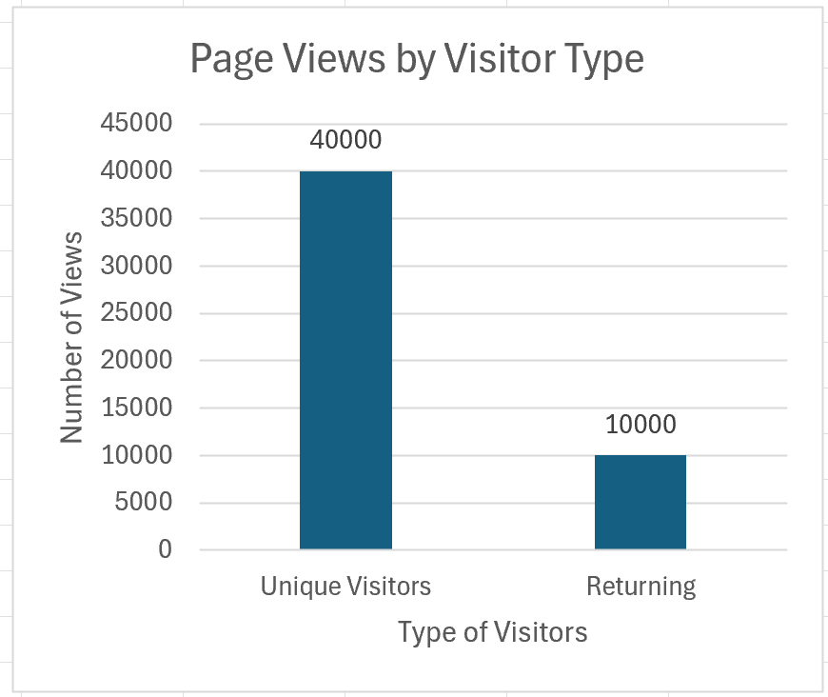

**Graph Interpretation**: A large gap between unique and returning visitors may suggest that the content is engaging on the first visit but lacks strong incentives for users to return (such as updated news or deeper analysis).

**Device Usage**:

On average, users spend 3.5 minutes on the article via desktop, 2.5 minutes via mobile, and 3.0 minutes via tablet. Desktop users tend to engage more deeply, potentially due to the larger screen and easier navigation. However, mobile users, comprising 30% of the traffic, show a need for mobile optimization to encourage longer sessions.

**Pie Chart**: This can illustrate the proportion of users accessing the article via desktop, mobile, or tablet devices.

|  |  |
| --- | --- |
| Device Type | Percentage |
| Desktop | 60% |
| Mobile | 30% |
| Tablet | 10% |

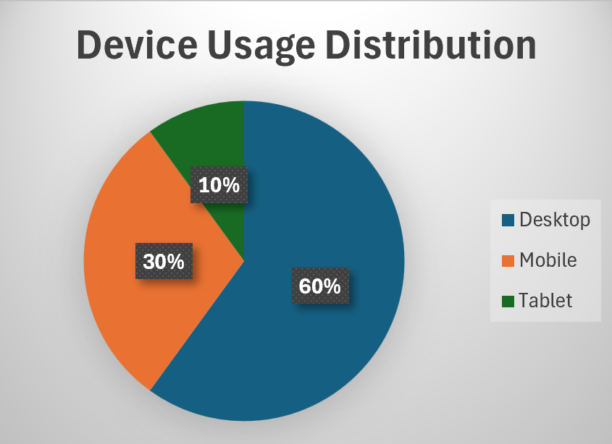

**Interpretation**: If mobile users show a shorter average time spent or higher bounce rate, optimizing the content for mobile (like improving load times or text formatting) could help retain these users.

**Average Time Spent on Page by Device**:

The majority of users access the article via **desktop (60%)**, followed by **mobile (30%)**, and **tablet (10%)**. Desktop users show higher engagement, with an average of 3.5 minutes spent on the page, while mobile users tend to leave quicker, suggesting a need for improved mobile responsiveness.

**Bar Graph**: Show how long users are spending on the page based on the device they use. For example:

|  |  |
| --- | --- |
| Device Type | Avg. Time Spent (min) |
| Desktop | 3.5 |
| Mobile | 2.5 |
| Tablet | 3.0 |

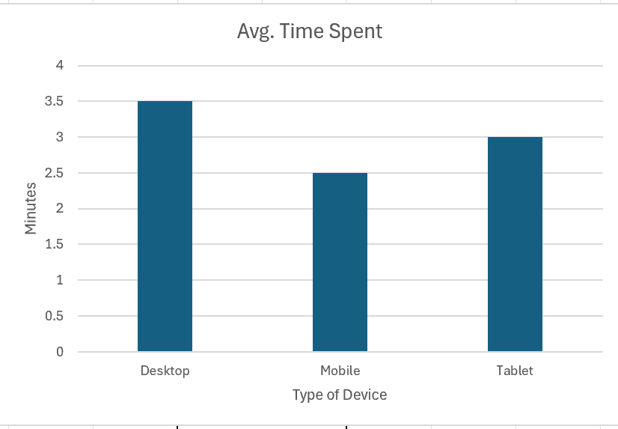

**Graph Interpretation**: A lower average time spent on mobile might suggest that mobile users aren't as engaged, potentially due to formatting issues or difficulty in navigating.

**Bounce Rate Over Time**:

**Line Graph**: This can show how the bounce rate has fluctuated over a set period, indicating when users are more likely to leave the page without interacting. A consistently high bounce rate suggests that many visitors leave after a brief view, indicating that either the content or presentation is not hooking readers

|  |  |
| --- | --- |
| Week | Bounce Rate (%) |
| Week 1 | 68 |
| Week 2 | 65 |
| Week 3 | 64 |
| Week 4 | 66 |
| Week 5 | 67 |
| Week 6 | 63 |
| Week 7 | 62 |
| Week 8 | 60 |

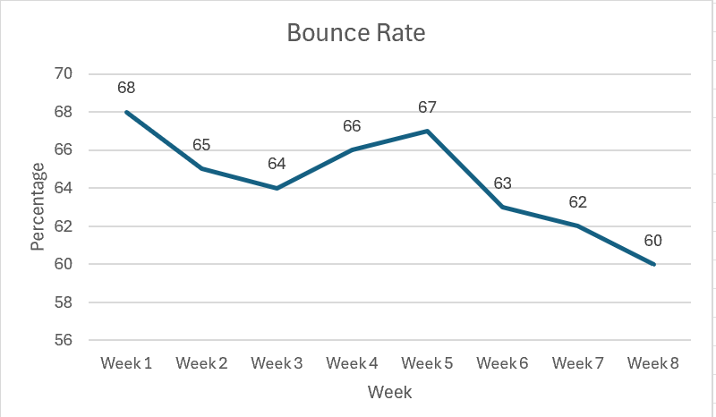

**Interpretation**:

The **line graph** will help visualize how the bounce rate is changing over time. A declining bounce rate might indicate that users are spending more time on the page, while an increasing or consistently high rate could suggest issues with user engagement (e.g., users leaving quickly without exploring further).

**Recommendations**

**Strategy 1: Optimize Content for Mobile Users**

Since 30% of traffic comes from mobile users, optimizing the article for mobile devices could help increase the average time spent on the page. This could include simplifying navigation, improving load times, and adjusting the design for smaller screens.

**Strategy 2: Enhance User Engagement with Interactive Content**

To reduce the bounce rate and increase the average time spent, adding interactive elements like embedded videos, quizzes, or related articles may encourage users to stay on the page longer. These features provide more opportunities for users to interact with the content, increasing overall engagement.